Session 8: Database Optimization with Indexes and Views
1. Objective
To improve query performance using indexing and to simplify complex data access through the creation of views within the Project-Hub database.

2. Implementation Queries
Task 1: Improve Search Performance (Email Index)
This creates an index so searching for a student by their email doesn't require scanning the whole table.
CREATE INDEX idx_student_email ON Student(Email);
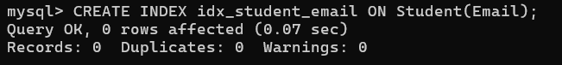
Task 2: Ensure Data Uniqueness (Username Index)
Assuming we add a Username column, this ensures no two people can have the same handle.
ALTER TABLE Student ADD COLUMN Username VARCHAR(50);
CREATE UNIQUE INDEX idx_unique_username ON Student(Username);
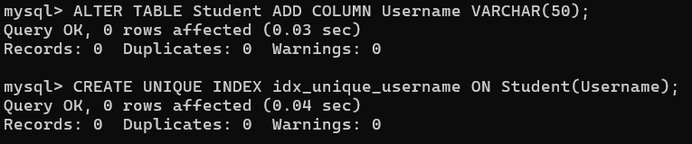
Task 3: Remove Unused Indexes
If an index is no longer needed, we drop it to save storage space.
DROP INDEX idx_student_email ON Student;
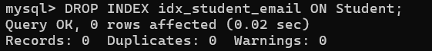
Task 4: Optimize Slow Identity Queries
Your syllabus mentions Aadhar, but for your project, we will optimize the VTU_Number search, which is your primary identifier.
CREATE INDEX idx_vtu_search ON Student(VTU_Number);
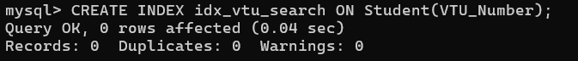
Task 5: Composite Indexing for Filters
This helps when you want to filter projects by their department and sort them by the date they were created.
CREATE INDEX idx_dept_date ON Student(Department, created_at);

Task 6: Create a View (Project-Hub Dashboard)
A View allows you to show project names and student names together without writing a JOIN every time.
CREATE VIEW Project_Dashboard AS
SELECT s.Name, c.Course_Name, c.Faculty_Email
FROM Student s
JOIN Course c ON s.VTU_Number = c.Student_ID;
-- To see the view:
SELECT * FROM Project_Dashboard;
